Postgresql trigger for Webhook on n8n
My conversation with AI

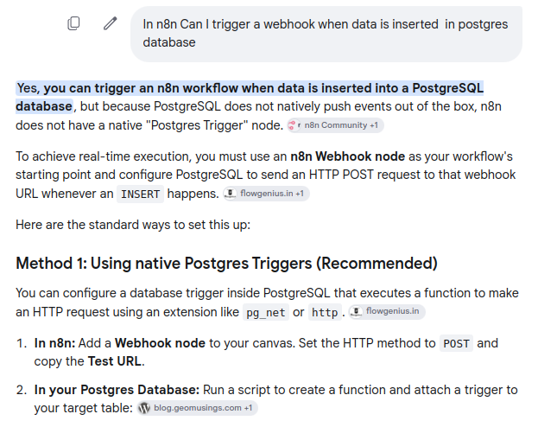

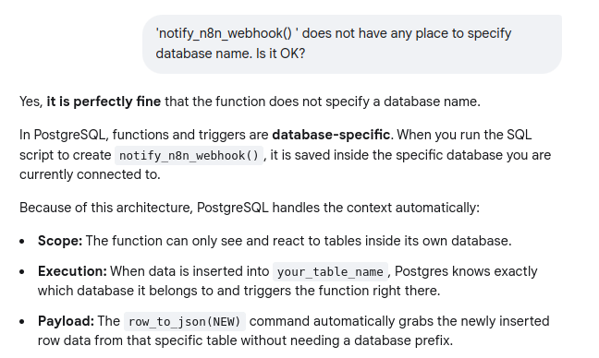

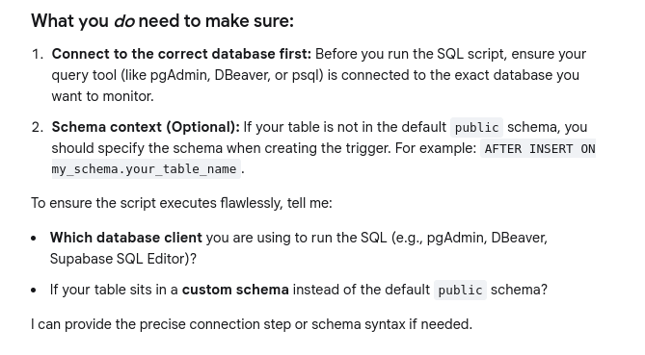

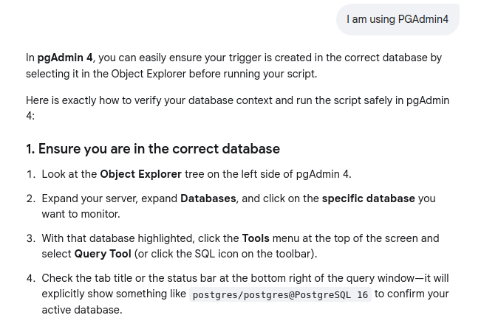

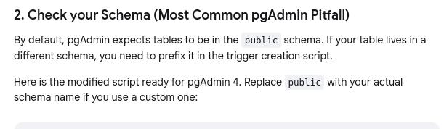

-- 1. Create the function inside the active database
CREATE OR REPLACE FUNCTION notify_n8n_webhook()
RETURNS TRIGGER AS $$
DECLARE
payload JSON;
BEGIN
payload = row_to_json(NEW);

PERFORM net.http_post(
url := 'https://your-n8n-instance.com',
body := payload::text,
headers := '{"Content-Type": "application/json"}'::jsonb
);
RETURN NEW;
END;
$$ LANGUAGE plpgsql;

-- 2. Bind it to your table (Adjust 'public' and 'your_table_name' as needed)
CREATE TRIGGER tr_after_insert_n8n
AFTER INSERT ON public.your_table_name
FOR EACH ROW
EXECUTE FUNCTION notify_n8n_webhook();

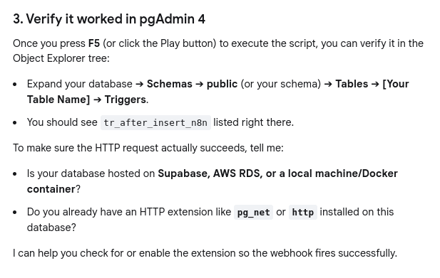

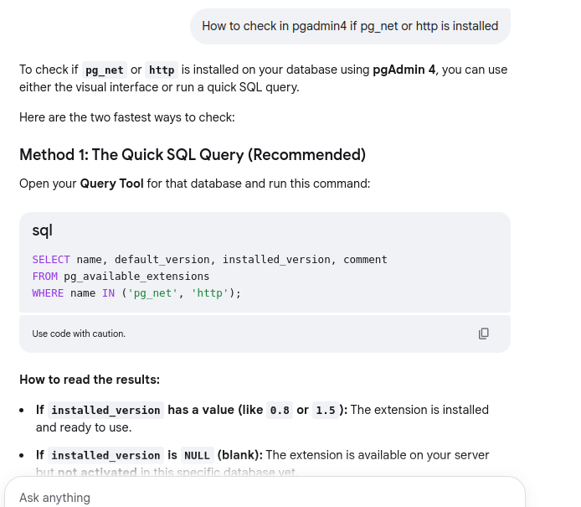

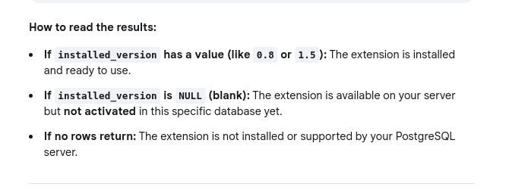

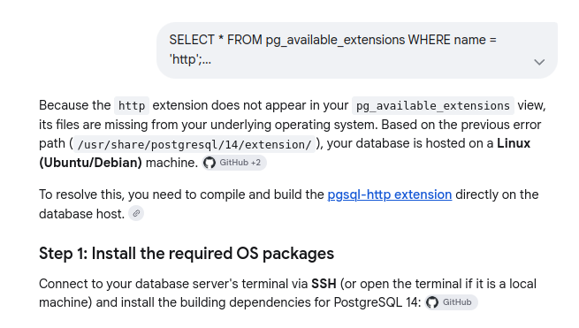

sudo apt-get update
sudo apt-get install -y postgresql-server-dev-14 libcurl4-openssl-dev build-essential git

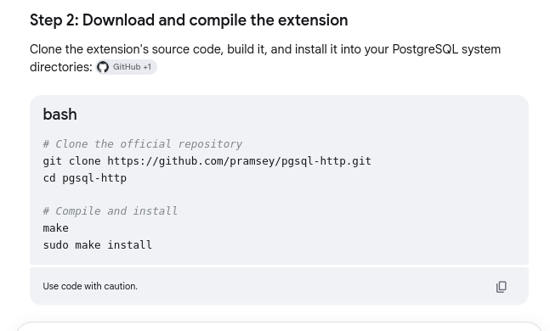

# Clone the official repository
git clone https://github.com/pramsey/pgsql-http.git
cd pgsql-http

# Compile and install
make
sudo make install

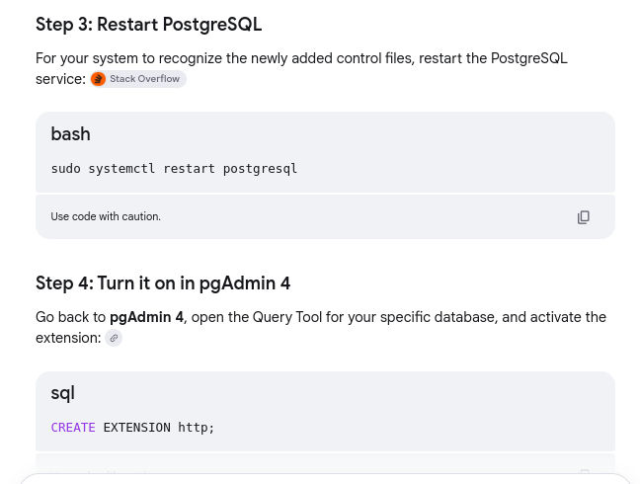

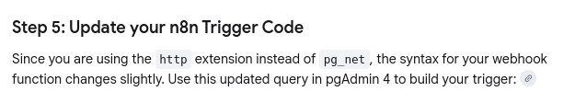

-- 1. Create the function using the 'http' extension syntax
CREATE OR REPLACE FUNCTION notify_n8n_webhook()
RETURNS TRIGGER AS $$
DECLARE
payload TEXT;
response http_response;
BEGIN
-- Convert the newly inserted row to text
payload := row_to_json(NEW)::text;

-- Send the HTTP POST request via the http extension
SELECT * INTO response FROM http_post(
'https://your-n8n-instance.com',
payload,
'application/json'
);

RETURN NEW;
END;
$$ LANGUAGE plpgsql;

-- 2. Bind it to your table
CREATE TRIGGER tr_after_insert_n8n
AFTER INSERT ON public.your_table_name
FOR EACH ROW
EXECUTE FUNCTION notify_n8n_webhook();

#################

